Using Canvas Accessibility Tools
LIFT Webinars: ADA Series (Dec. 2025)

Recommended workflow:
- Run the UDOIT checker and fix the issues you can within the tool (skip any issues that require you go to the page to fix it).
- Go page by page and use the Canvas Accessibility Checker and self-check items.
- Document and develop a plan for completing any remaining work. In the meantime, you will need to provide accommodations if a student requests it.
Note: Some issues show up in both tools, so we chose the tool that makes it easiest to fix.
Learn more from Steps for Making a Course Accessible (some resources unavailable).

Cidilabs’ “Course Accessibility Checker (UDOIT)”

Enabling UDOIT
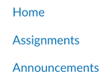
- Check your course settings. Go to the Navigation tab in Course settings. Find the tool and drag it up. This step must be taken for every course.
- In the course navigation, click on the tool. If prompted, click “Authorize” to allow UDOIT access to your account.

Using UDOIT
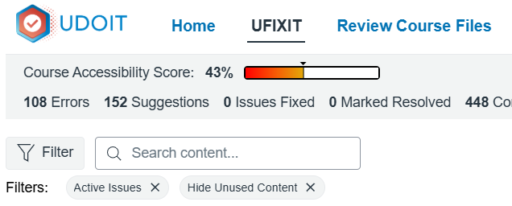
- In the Course Navigation, click “Course Accessibility Checker (UDOIT)”.
- Click on the UFIXIT tab.
- Set filters by clicking on the “Filter” button. Set the following: Issue Status – Active, Issue Severity - Errors, Hide Unused Content.
Note: Errors are known issues. Suggestions may be issues but need your judgment. Learn more with the UDOIT User Guide.

Common UDOIT Improvements

Hyperlinks
Follow these guidelines to ensure hyperlinks are meaningful:
✅ Do | ❌ Don’t
Make link text contextual and descriptive | Say “click here”, “read more”, or use URL as link text
Use Canvas native styling for hyperlinks | Remove the underline

Font Color/Contrast
You can use color if paired with bold or italics, for example. However, we recommend not using color because it can create other accessibility issues.
✅ Do | ❌ Don’t
Use icons, bold only, or headings | Use color for emphasis
Follow color contrast ratios

Alt Text
First, decide if the image is essential to understand the content or not. If it’s not, you can mark it decorative. If it is essential, Alt text is required. If your alt text exceeds 120 characters, reach out to your accessibility office for guidance.
✅ Do | ❌ Don’t
Use 120 characters or less | Use the file name as the alt text
Mark non-essential images as decorative

Tables (headers and scope attributes)
You might get two related error messages:
- Does not include header rows or columns.
- Table headers are missing row or column scope attributes.
This is an example of a table with a header row. Each header cell has the scope set to “column,” because it is the title for the cells in that column.
Group 1 | Group 2 | Group 3
Jim | Jose | Shang
Maya | Mary | Elliott
In the example below, you have a header row and a header column (“both”).
Week | Topic | Readings
Week 1 | Intro to Communication | Chapter 1
Week 2 | Written Communication | Chapter 2
Learn more about fixing tables in Canvas.

Canvas’ Native “Accessibility Checker”

How to Use the Tool
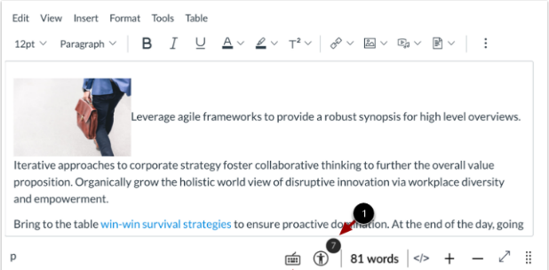
Step 1. Edit the page/assignment/etc.
Step 2. Look for the indicator, which will display
the number of common errors found in the page.
- Run UDOIT and fix the identified issues.
- Check each individual page, discussion, etc. using the
Canvas Accessibility Checker and fix the issues.
2. Accessibility Checker indicator

Common Canvas Accessibility Checker & Self-Check Improvements

Semantic Headings
Nest headings from H1 to H5, using Canvas native headings using the paragraph drop down menu in the Canvas Accessibility Checker. See the “Change Text Style” section.
✅ Do | ❌ Don’t
Use headings in sequential order | Skip headings (e.g. H2 followed by H4)
Use Canvas native headings | Copy/paste from word or other online resources

Tables (captions)
Follow the Canvas Accessibility Checker to add table captions. For complex tables (e.g. nested, merged or split cells), contact your Accessibility Office.
✅ Do | ❌ Don’t
Add a caption | Copy/paste tables from Word or online resources
Reformat tables as a list if a list conveys the information just as well | Use tables for formatting images on a page

Alt Text
Self-check to ensure images are correctly marked as decorative. Click on the image and click “image options”. Learn how to open image options.

Fonts
Self-check that fonts are at least 12 pt and use Canvas native paragraph style. Only use bold and/or italics for emphasis. Highlight your text (e.g. a single word or a whole page). Click the clear formatting button. See the “Remove Text Formatting” section.
