Making Your Documents Accessible
LIFT Webinars: ADA Series (Jan. 2026)

Overview
Follow the 3-step process below to make your Word documents and PDFs compliant with the new ADA requirements.

Part 1: Assess the Scope of Work Using TidyUP
TidyUP is a Canvas’ enabled tool by Cidi Labs which can help you declutter your course of unused, unneeded, unwanted content. It will also help you narrow the scope of your accessibility efforts to those documents in your file area that are student-facing.

Enable the Tool
This only needs to be done once per course.
- Go to the Course settings (left hand navigation tabs) and then the Navigation tab (at the top of the settings page).
- Find the TidyUP tool and drag it up to the visible navigation area. This step must be taken for every course when using the tool for the first time in each course.
- Click Save.
For more detailed instructions to enable the tool, see the TidyUp User Guide Canvas course for Getting Started.

Scan
Open the TidyUp tool from the right-hand navigation. Click “Scan Course.”

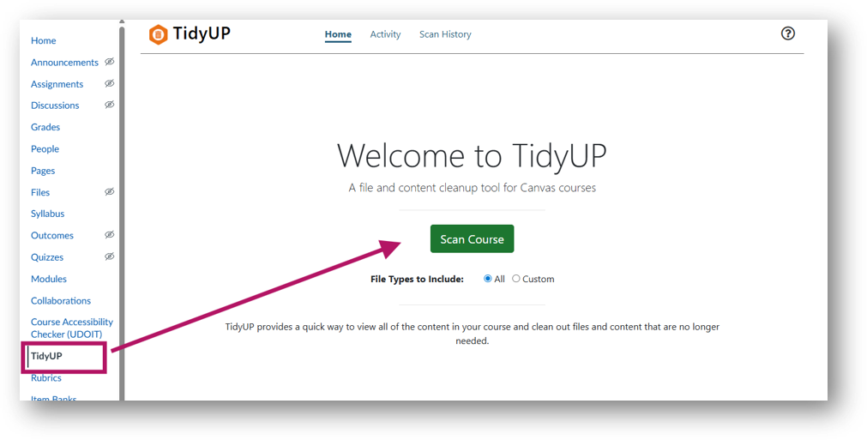Filter and Download (Student-Facing) Documents
In the Files tab, filter the results list to show only student-facing documents in the course. These will be the documents you will need to make accessible.
- Select Show>>Files in Use.
- Download all documents that are student-facing.
- Save them to a folder of your choosing.
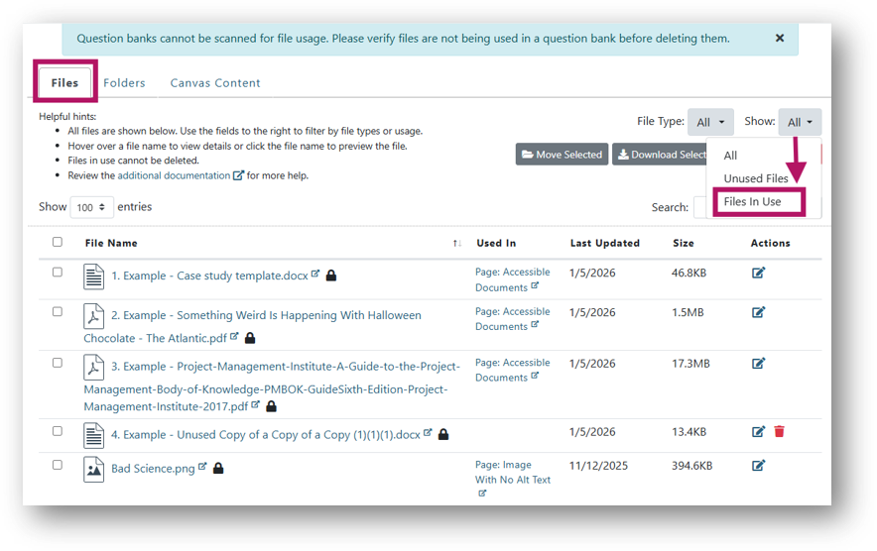

Part 2: Remediate Your Documents

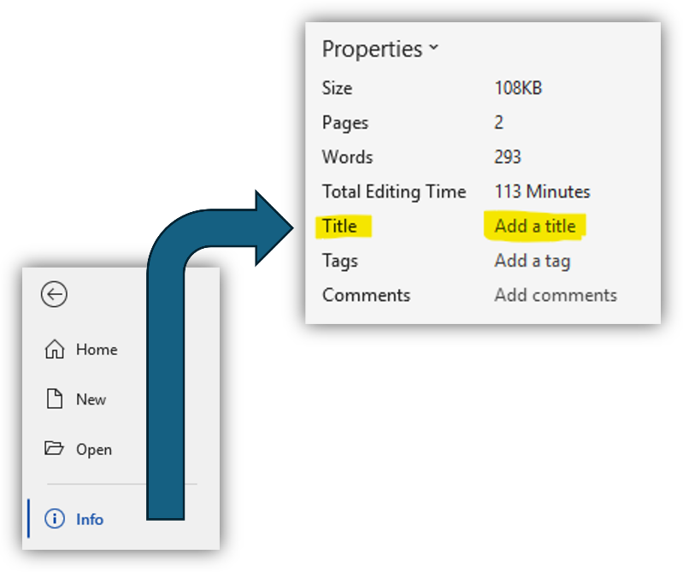
Microsoft Word
- Manually add these elements if missing:
  - Title (under File > Info > Properties)
  - Headings
  - Alternative text for images
    - NOTE: These are the elements that will be flagged in UDOIT if missing.
- Run the Accessibility Assistant
  - Under the Review tab, click on Check Accessibility
  - Note that the AI can be inconsistent; you will still want to scan the document to make sure you include descriptive hyperlinks and not using color alone for emphasis.

PDFs
- Before you start: For new documents not stored in your course, make sure you have a backup copy.
  - The tool may occasionally glitch and erase all content.
  - If you notice this before being prompted to save, select No—though this issue isn’t always obvious.
- Open a course file in Adobe Acrobat
- Use the built in Guided Action tool
  - All Tools > View more > Use guided actions > Make Accessible > Add files
    - TIP: You can drag the “Use guided actions” item up to the top of your “All Tools” panel
- After adding as many files as desired, click “Start.”
- Save each file and update the title as needed.

Part 3: Replace Documents in Canvas

Replacement Process
In the Canvas navigation bar, open Course Accessibility Checker (UDOIT).
- Change the filter so you can see all the files.
- Replace files directly.
  - Click Review > Replace File with an Uploaded File
  - Select or drag your accessible document into the document upload area.
  - Select Submit.
UDOIT will scan each of the replacement documents and alert you if it finds any further accessibility issues.
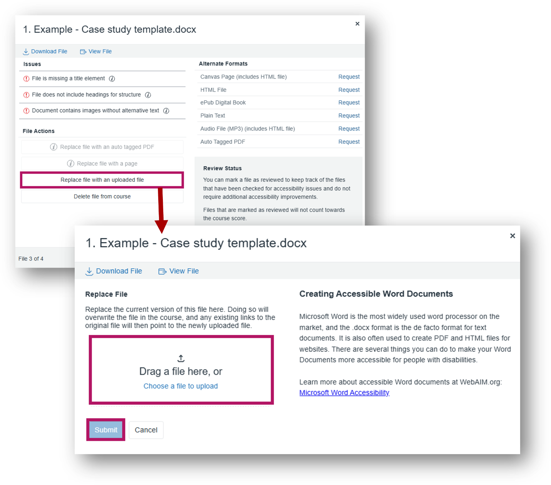

File Hygiene for Future Courses
- Keep one file per document in the Canvas course
  - Archive outdated versions elsewhere on your computer
- Use clear, consistent file names
- Use versioning in file names

Problem-Heavy PDFs?
Here are some questions to ask if you have a PDF with many issues:
- Is this a publisher file?
  - Ask for an accessible copy
- Is there a more accessible alternative? Consider:
  - Websites
  - Canvas page
  - Original files (PowerPoint, Word)
  - Online forms tool
  - Campus library links (non-OPLR courses)
- Contact your Accessibility Office with questions!

Resources
- Campus Resources
  - Disability Services
  - Centers for Teaching and Learning
- Cidi Labs Tools
  - TidyUP Course Cleanup Tool for Canvas
  - TidyUP User Guide Canvas Course
  - What Does UDOIT Look For?
- Adobe
  - Accessibility Features in PDFs
- Microsoft
  - Make Your Word Documents Accessible to People with Disabilities
  - How to Create Accessible PowerPoint Presentations
  - Accessibility Best Practices with Excel Spreadsheets
- General
  - Add document title into word document or pdf

